
Portable broadband UAV detection equipment
User Manual

catalogue
1、 Declaration and Safety Notice 1
（1） Copyright Statement 1
（2） Responsibility Statement 1
（3） About this manual 1
（4） Instructions for Use 1
2、 Battery safety precautions 1
（1） Strictly prohibit charging 1
（2） Maintenance Notice 1
（3） Transportation Notice 2
3、 Preparation before use 2
（1） Install Attachment 2
（2） Install antenna 2
（3） Install belt clamp 2
（4） Install battery pack 2
4、 Battery pack charging 2
5、 Introduction to Detection Equipment 3
VI LCD Display Icon Description 3
7、 Basic Operation 3
（1） Startup and Shutdown 3
（2） Adjust volume 3
（3） Real time alarm function 4
（4） Alarm light display function 4
（5） Device Configuration Function 4
（6） One click mute function 4
8、 Main functional features 5
9、 Main technical indicators 5
10、 Configuration modification 5
（1） Language Configuration 6
（2） Time and date configuration 6
（3） Brightness adjustment configuration 6
（4） Vibration regulation configuration 7
（5） Sensitivity adjustment configuration 7
（6） Device Mode Configuration 7
（7） Log configuration 8
11、 Troubleshooting Guide 8
12、 Maintenance and Cleaning 8
（1） Maintenance 8
（2） Cleaning 9
13、 Device operation and maintenance 9
14、 Inspection and maintenance 9

Declaration and Safety Notice

Copyright Notice
- Without the written permission of our company, no unit or individual may extract or copy any part or all of the content of this manual, and may not disseminate it in any form.
- The products described in this manual may include software copyrighted by our company and its potential licensors. Without the permission of the relevant rights holder, no one is allowed to copy, distribute, modify, excerpt, decompile, disassemble, decrypt, reverse engineer, rent, transfer, sublicense, or engage in any other infringement of software copyright in any form.

Responsibility Statement
- Our company shall not be liable or liable for any special, incidental, consequential, or indirect damages arising from the use of this manual or our products, including but not limited to loss of commercial profits, loss of data or documents.
- The products described in this document are provided "as is" and unless required by applicable law, this manual is only intended as a guide for use. All statements, information, and recommendations do not constitute any express or implied warranties, including but not limited to warranties of merchantability, quality satisfaction, suitability for a particular purpose, non infringement of third-party rights, etc.

About this manual
- This manual is for use with multiple models of products. Please refer to the actual product for appearance and functionality.
- This manual comes with multiple software versions. Please refer to the actual software for the product interface and functions.
- The content of this manual may contain technical errors or printing errors, and the final interpretation by our company shall prevail.
- Any losses caused by failure to follow the instructions in this manual shall be the responsibility of the user.
- Our company reserves the right to modify any information in this manual without notice or prompt. Due to product version upgrades or legal requirements in relevant regions, the content of this manual will be updated periodically, and the updated content will be reflected in the new version.

Instructions for use
During the use of this product, please follow the following precautions to avoid property damage or personal injury:
- Do not use unauthorized or damaged accessories.
- Do not place this product above the airbag or within reach of the airbag after deployment.
- Do not place this product and its accessories within reach of children and pets.
- Please use this product within the specified operating temperature range.
- High temperature environment can cause the body to heat up, please let this product cool down by placing it still.
- Always apply force when pressing the button, and avoid using too much force.
- Please do not disassemble, modify or repair this product and its accessories without authorization.

Battery safety precautions

Strictly prohibit charging
Charging operations are strictly prohibited in the following places or situations to avoid property damage or personal injury:

Charging or replacing batteries is strictly prohibited in places where fuel, chemicals, explosive gases, and other flammable and explosive materials are stored.

When the battery or terminal is accidentally damp, please dry it with a clean dry cloth before charging, otherwise charging is strictly prohibited.

When the battery experiences abnormal conditions such as leakage, deformation, or overheating, it is strictly prohibited to charge it.

It is strictly prohibited to use unauthorized chargers for charging.

It is strictly prohibited to charge near strong radiation sources.

It is strictly prohibited to overcharge the battery, otherwise it will affect the battery life.

Maintenance Notice
To ensure the normal operation of the battery and extend its lifespan, please follow the following precautions:

Dust accumulation on battery electrodes may affect normal charging, so please clean the battery promptly with a clean dry cloth.

It is recommended that the ambient temperature during charging be between 5 ℃ and 40 ℃. Charging at temperatures that are too high or too low can shorten the battery life and even cause leakage.

If you want to charge a terminal with a battery installed, it is recommended to turn off its power during charging to ensure that the battery is charging properly.

Do not plug or unplug the power supply and battery during charging to avoid interfering with the normal charging process.

Do not dispose of batteries in fire.

Do not expose the battery to direct sunlight for a long time or place it near other heat sources.

Do not squeeze, prick or disassemble the battery casing without authorization.

Transportation Notice

Do not transport damaged batteries.

Ensure that the batteries inside the packaging box do not experience short circuits. If there are multiple batteries in the same packaging box, please package each battery separately.

If the device is equipped with a battery, it must be turned off and measures must be taken to prevent accidental power on.
The transportation documents should list the details of the transported items and indicate them on the packaging box with a battery transportation label. For local laws, regulations, and other information, please contact your carrier.

Preparation before use

Install attachments
Antenna, belt clip, battery pack.

Install antenna
Rotate the antenna clockwise until it is tightened. To remove the antenna, rotate counterclockwise.
Attention: Do not hold the top of the antenna and shake this product, otherwise it will reduce the working performance and service life of the antenna of this product.

Install belt clamp
Install the belt clamp onto the back of the device using the two accompanying screws.

Install battery pack
Before installing or removing the battery, make sure to completely turn off the device by turning the power/volume knob counterclockwise.

To install the battery pack:
- Turn the back of the device towards you and insert the lithium-ion battery pack into the back of the device.
- Push the bottom of the battery upwards, and the battery lock key locks the battery.

To remove the battery pack:
- Turn the back of the device towards you and press the battery lock button downwards.
- Hold down the battery and pull it back until the battery pack is completely separated from the device.

Battery pack charging
Attention: Please ensure that this product is turned off when charging.
Please use our designated charging dock to charge the battery.
- Insert the plug of the power adapter into the power outlet.
- Insert the other end of the power adapter into the socket on the back of the charging dock.
- Insert the battery or the product with the battery correctly into the charging dock.
remarks:
For optimal battery performance, please charge for at least 8 hours on the first charge.

Introduction to Detection Equipment
The portable broadband drone detection device adopts a low-power design and highly integrated design, capable of detecting mainstream DJI, Daotong and other rotary wing drones using OFDM high-definition image transmission, as well as various DIY crossings using analog image transmission signals. The device adopts dual antennas and multi-channel simultaneous scanning, which has the characteristics of fast detection speed, high detection sensitivity, long detection distance, low false alarm rate, strong scalability, and easy use.
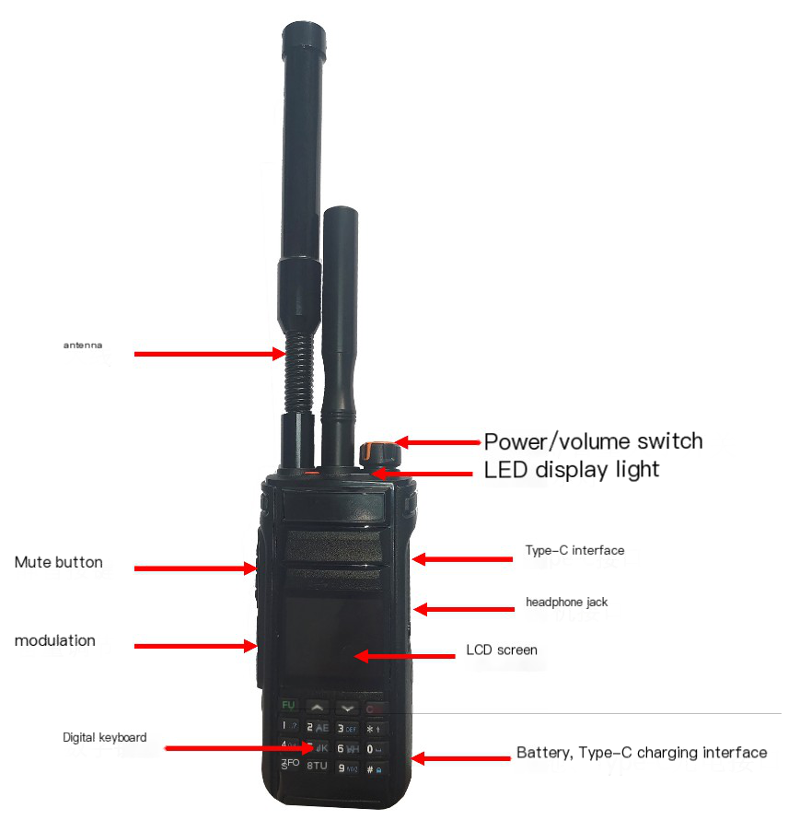
Detection equipment

LCD Display Icon Description
Icon | describe
 | The numerical value displayed in the upper left corner of the screen indicates the device time
 | Device mute displayed in the upper right corner of the screen
 | The device battery level is displayed in the upper right corner of the screen
 | Display the detected types of drones
 | Display the detected drone frequency
 | Display the detected drone frequency intensity values
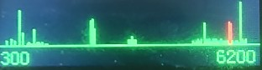 | The red display of the detected spectrum range indicates that a drone has been detected at this frequency

basic operation

Powering on
To turn on the device, please rotate the power switch/volume control knob clockwise until you hear a "click" sound. To shut down, please turn this knob counterclockwise until you hear a "click" sound.

Adjust the volume
After turning on, rotate the power switch/volume control knob clockwise to increase the voice reception volume, and counterclockwise to decrease the voice reception volume. Or adjust the volume through the volume button on the right side of the device.
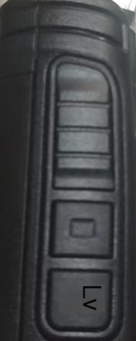

Real time alarm function
After booting up, the middle part of the screen automatically displays the list of drone alarms and real-time spectrum maps around it.
The alarm list lists the drone type (DJ \ DJO4 \ AUTEL \ FPV, etc.), frequency (MHz), signal strength (maximum 128), and displays up to the last 5 alarms.
Real time spectrum map displays real-time spectrum information near the device (300MHz-6200MHz), and the frequency of drone alarm information is displayed with a red line. The longer the line, the stronger the signal.
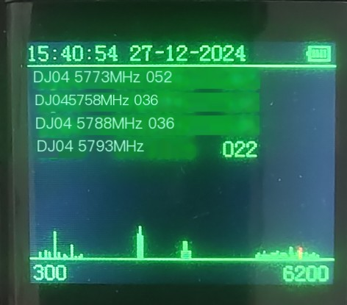
Screen display interface

Alarm light display function
After booting up, the device receives a drone alarm, and there is an LED light on the top of the device that displays the alarm. If a drone is detected, it will flash red, and if no drone is detected, it will flash green.
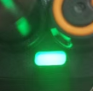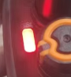

Equipment configuration function
The device supports sound alarm function. Press the "#" key and the screen will display the system configuration interface.
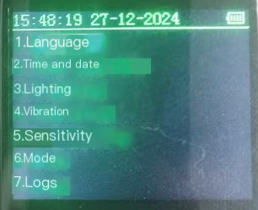
Screen configuration interface

One click mute function
The device supports one click mute function. Press and hold the upper button on the right side of the device for 3 seconds to enter mute mode and display the mute icon on the screen. After long pressing for 3 seconds, press the volume button to unmute.
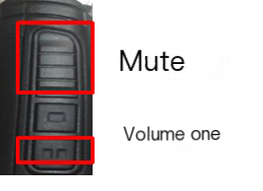

Main functional features
Passive Detection of Drones: Able to identify rotary wing drones such as DJI and Daotong that use OFDM high-definition image transmission; Can detect various types of time traveling machines using analog image transmission within 300MHz-6200MHz.
Sound and light alarm: headphone sound alarm, external sound and light alarm.
Log recording: It has alarm log recording and can export alarm logs through USB interface.
Headphone function: capable of obtaining alarm sound through headphones.
Firmware upgrade function: Upgrade firmware through the Type-C interface.
Multi language switching: supports English and Russian.
Work status display: time, battery level, equipment status
Working modes: default mode, key frequency band scanning mode (later supported), user-defined feature library scanning mode (later supported).
Custom detection: Users can modify, delete, or add detection drone feature libraries through the type-c interface.

Main technical indicators
name | Related parameters
Receiving frequency band | 300MHz-6200MHz
Identify type | OFDM high-definition image transmission signal, time traveling machine FM analog image transmission
Detecting distance | ≥1km
Detection sensitivity | Better than -96dBm
Detecting alarm methods | Headphones, sound and light
Log recording | Support no less than 500 alarm records
Upgrade and data export interface | type-c
power supply | Detachable lithium battery (Type-C charging)
Battery life | ≥ 6 hours (single battery)
structure size | ≤ 135mm × 60mm × 35mm (host without antenna)
Working weight | ≤ 500g (including single battery)
Startup method | Knob button, rotate to start
Control method | Key operation, supporting sound adjustment, screen backlight on, and drone detection information viewing function
- Note: All specifications are subject to change without prior notice or liability.

Configuration modification

Language configuration
Press the "#" key to enter the system configuration interface. You can switch configuration options through the "▲" and "▼" arrow buttons. In the "1. Language" language option, press and then press the green "FUN" key to enter the language configuration interface. Press the "*" key to switch the system language, then press the red "CLR" key to confirm and return to the previous menu.
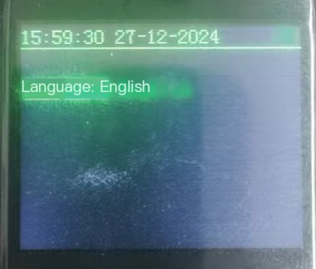

Time and date configuration
Press the "#" key to enter the system configuration interface. You can switch configuration options through the "▲" and "▼" arrow buttons. In the "2. Time and date" option, press and then press the "FUN" key to enter the time configuration interface. Use the "1" and "2" numeric keys to move the cursor, then use the "▲" and "▼" arrows to modify the time, and press the "FUN" key to confirm. The screen displays "set OK" indicating successful modification. Press the "CLR" key to return to the previous menu.
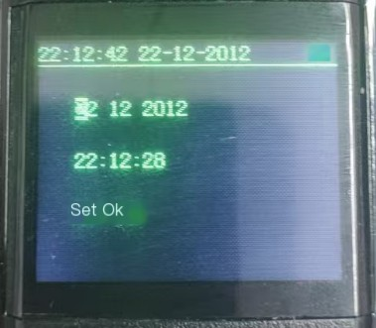

Brightness adjustment configuration
Press the "#" key to enter the system configuration interface. You can switch configuration options through the "▲" and "▼" arrow buttons. In the "3. Lighting" option, press and then press the "FUN" key to enter the brightness adjustment interface. Use the "▲" and "▼" arrows to move the cursor up and down. In the "Key" option, press the "*" key to modify the keyboard brightness display. In the "Lcd" option, press the "*" key to modify the "high, medium, and low" brightness of the screen brightness. Press the "CLR" key to confirm and return to the previous menu.
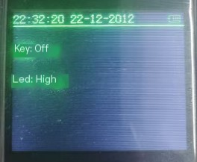

Vibration regulation configuration
Press the "#" key to enter the system configuration interface. You can switch configuration options through the "▲" and "▼" arrow buttons. In the "4. Vibration" option, press and then press the "FUN" key to enter the vibration adjustment interface. Press the "*" key to modify the vibration, press the "CLR" key to confirm and return to the previous menu.
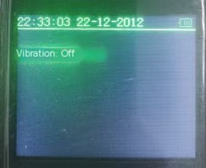

Sensitivity adjustment configuration
Press the "#" key to enter the system configuration interface. You can switch configuration options through the "▲" and "▼" arrow buttons. In the "5. Sensitivity" option, press and then press the "FUN" key to enter the sensitivity adjustment interface. Press the "*" key to modify the sensitivity to "high, medium, or low". Press the "CLR" key to confirm and return to the previous menu.
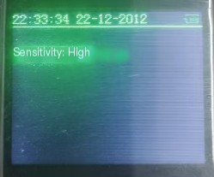

Equipment mode configuration
Press the "#" key to enter the system configuration interface. You can switch configuration options through the "▲" and "▼" arrow buttons. In the "6. Mode" option, press and then press the "FUN" key to enter the device working mode interface. Press the "*" key to modify the "standard" and "Eco" modes of the working mode. Press the "CLR" key to confirm and return to the previous menu.
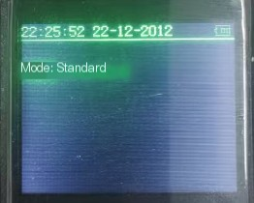

Log configuration
Press the "#" key to enter the system configuration interface. You can switch configuration options through the "▲" and "▼" arrow buttons. In the "7. Logs" option, press and then press the "FUN" key to enter the log configuration interface. In the "Recordings" option, press the "*" key to turn on/off the log recording function. In the "Erase" option, press the "*" key to clear the log recording. Press the "CLR" key to confirm and return to the previous menu.
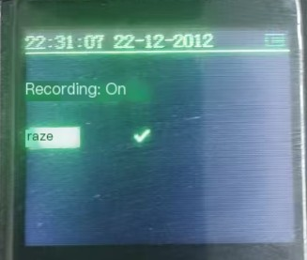

Troubleshooting Guide
problem | resolvent
No power supply, unable to turn on | The battery may not be installed properly, please remove the battery and reinstall it  The battery may be depleted, please replace the battery or charge it before use
No drone detected | The drone is not within the detection range of the device  The drone is not within the detection frequency range of the device  Lack of drone library, activate scanning function for detection
The standby time is too short | Regularly maintain the battery to prevent virtual charging  Confirm to turn off the lighting and vibration functions  Regularly replace the battery to prevent its capacity from decreasing over time  The battery life has expired (approximately 300 cycles of charging and discharging), please replace the battery
- If the above methods still fail to solve your problem, or if you encounter some other malfunctions, please contact your local dealer for more technical support.

Maintenance and Cleaning
In order to ensure the good performance of this product and extend its service life, please familiarize yourself with the following content for better daily maintenance and cleaning of this product.

maintain

Do not puncture or scratch this product with hard objects.

Do not store this product in environments containing corrosive electronic circuit materials.

Do not use handheld antennas while carrying or using this product.

When not using attachments, please cover the attachment interface cover.

clean
Note: Before cleaning, please turn off the device and remove the battery.

Please regularly use a clean and dry lint free cloth or brush to wipe off the dust attached to the surface of this product and the charging electrode.

The buttons, control knobs, and casing of this product are highly susceptible to dirt. It can be cleaned with neutral detergent and non-woven cloth. Do not use detergent, alcohol, spray or petroleum preparation and other chemical agents to avoid damage to the product surface and shell.

After cleaning, be sure to ensure that this product is completely dry, otherwise do not use it.

Device operation and maintenance

Appearance inspection
- Plastic surface and screen: Regularly check for cracks, scratches, or dirt, and clean the surface with a soft cloth and appropriate cleaning agent.

Battery maintenance
- Regularly charge and discharge to avoid prolonged periods of fully charged or empty state, in order to extend battery life.
- Monitor the health status of the battery. If the battery life is significantly reduced, replacement should be considered.
- Avoid storing batteries in high or low temperature environments for extended periods of time.

Battery charger
- Regularly inspect the adapter cables and plugs for damage.

functional testing
- Regularly test the various functions of the equipment to ensure normal operation.

Safety precautions
- Use original or certified accessories.
- Avoid using the equipment under humid or extreme temperature conditions.
- Regularly check the equipment for any abnormal phenomena such as overheating and odor.

Inspection and maintenance
Serial number | Operation and maintenance project | Inspection/maintenance content | frequency | remarks
1 | Appearance inspection | Plastic surface and screen cleaning and integrity | monthly
2 | Battery maintenance | Battery charging and discharging cycle | monthly | Record the health status of the battery
3 | Battery maintenance | Avoid extreme temperature environments | Continuous monitoring
4 | Battery charger | Cable and plug inspection | monthly
5 | functional testing | Equipment functional testing | Quarterly | Record test results
6 | Safety precautions | Use original/certified accessories | Continuous monitoring
7 | Safety precautions | Avoid humid/extreme temperature environments | Continuous monitoring

